ISO 20022

Collateral Management - Maintenance 2021 - 2022

Message Definition Report Part 1

Approved by the Securities SEG on 20 January 2022

This document provides information about the use of the messages for Collateral Management and includes, for example, business scenarios and messages flows.

February 2022

Table of Contents

Table of Contents 2

1 Introduction 5

1.1 Terms and Definitions 5

1.2 Abbreviations and Acronyms 5

1.3 Document Scope and Objectives 6

1.4 References 6

2 Scope and Functionality 7

2.1 Background 7

2.2 Scope 7

2.3 Groups of MessageDefinitions and Functionality 8

3 BusinessRoles and Participants 10

3.1 Participants and BusinessRoles Definitions 10

3.2 BusinessRoles and Participants Table 11

4 BusinessProcess Description 12

5 Description of BusinessActivities 14

5.1 Margin Call Acceptance & Propose Collateral 14

5.2 Margin Call Proposal Rejection 15

5.3 Margin Call Cancellation 16

5.4 Margin Call Dispute 17

5.5 Rescind Call Response 18

5.6 Accept or Reject Substitution Request 20

5.7 Substitution Return Request 21

5.8 Accept Interest Payment Request 22

5.9 Dispute Interest Payment Request – Value Date Only 22

5.10 Dispute Interest Payment Request – Non Value Date Attribute 23

6 BusinessTransactions 24

6.1 Margin Call 24

6.2 Substitution 27

6.3 Interest Payment 29

6.4 Collateral Reporting 31

Revision Record 32

Preliminary note:

The Message Definition Report (MDR) is made of three parts:

- MDR - Part 1 describes the contextual background required to understand the functionality of the proposed message set. Part 1 is produced by the submitting organisation that developed or maintained the message set in line with a MDR Part1 template provided by the ISO 20022 Registration Authority (RA) on [www.iso20022.org](http://www.iso20022.org)

- MDR – Part 2 is the detailed description of each message definition of the message set. Part 2 is produced by the RA using the model developed by the submitting organisation.

- MDR – Part 3 is an extract of the ISO 20022 Business Model describing the business concepts used in the message set. Part 3 is an Excel document produced by the RA.

# Introduction

## Terms and Definitions

The following terms are reserved words defined in ISO 20022 Edition 2013 – Part1. When used in this document, the UpperCamelCase notation is followed.

|  |  |
| --- | --- |
| Term | Definition |
| BusinessRole | Functional role played by a business actor in a particular BusinessProcess or BusinessTransaction. |
| Participant | Involvement of a BusinessRole in a BusinessTransaction. |
| BusinessProcess | Definition of the business activities undertaken by BusinessRoles within a BusinessArea whereby each BusinessProcess fulfils one type of business activity and whereby a BusinessProcess may include and extend other BusinessProcesses. |
| BusinessTransaction | Particular solution that meets the communication requirements and the interaction requirements of a particular BusinessProcess and BusinessArea. |
| MessageDefinition | Formal description of the structure of a message instance. |

1. When a MessageDefinition or message identifier is specified, it should include the variant and version number. However, in this document (except in the business examples section, if present), variant and version numbers are not included. In order to know the correct variant and version number for a MessageDefinition, the related Message Definition Report Part 2 document should be consulted.

## Abbreviations and Acronyms

The following is a list of abbreviations and acronyms used in the document.

|  |  |
| --- | --- |
| Abbreviation/Acronyms | Definition |
| ACK | Acknowledgement |
| B/D | Broker/Dealer |
| CCP | Central Counterparty |
| CNS | Continuous Net Settlement |
| CSD | Central Securities Depository |
| EACH | European Association of Central Counterparty Clearing Houses |
| EnI | Exceptions and Investigations |
| ESCH | European System of Central Banks |
| ESCR | Committee of European Securities Regulators |
| FI | Financial Institution |
| FIA | Futures Industry Association |
| FOA | Futures and Options Association |
| GCM | General Clearing Member |
| ICM | Individual Clearing Member |
| ICSD | International Central Securities Depository |
| IDB | Inter-dealer/broker |
| ISITC | International Securities Association for Institutional Trade Communication |
| MDR | Message Definition Report |
| NCM | Non-Clearing Member |
| NAK | Negative acknowledge (reject) |
| SBF | Société de Bourse française (now Euronext) |
| SEG | Standards Evaluation Group |
| SLA | Service Level Agreement |
| SMPG | Securities Market Practice Group (www.smpg.info) |
| TM | Trading Member |
| XML | eXtensible Mark-up Language |

## Document Scope and Objectives

This document is the first part of the Collateral Management Message Definition Report (MDR) that describes the BusinessTransactions and underlying message set. For the sake of completeness, the document may also describe BusinessActivities that are not in the scope of the business processes covered in this document.

This document describes the following:

* the BusinessProcess scope
* the BusinessRoles involved in these BusinessProcesses

The main objectives of this document are as follows:

* to provide information about the messages that support the business processes
* to explain the BusinessProcesses and BusinessActivities these messages have addressed
* to give a high level description of BusinessProcesses and the associated BusinessRoles
* to document the BusinessTransactions

The messages definitions are specified in Collateral Management Message Definition Report Part 2.

## References

|  |  |  |  |
| --- | --- | --- | --- |
| Document | Version | Date | Author |
| ISO 20022 Business Justification – Collateral Management |  | 2010-04-30 | SWIFT, FPL, ISDA/FpML and ISITC |
| ISO 20022 Collateral Management Maintenance Change Request 2020/2021 | MCR # 176 | 2020-08-31 | SWIFT |
|  |  |  |  |

# Scope and Functionality

## Background

This Message Definition Report covers a set of fourteen ISO 20022 MessageDefinitions developed by SWIFT in close collaboration with FPL, ISDA/FpML and ISITC. These messages are specifically designed to support the bilateral Collateral Management process.

The use of collateral, or collateralisation, is nothing new as it has been with us for centuries[1]. It is used particularly within the repurchase agreement, securities lending and over-the-counter (OTC) derivatives markets, but it is also used between the central counterparties (CCPs) and their clearing members (CMs) to ensure the risk is mitigated during transaction processing. The primary function of collateral management, among others, is to protect one party against the credit risk of another party.

The rationale for using collateral has changed little over the years since it was first deployed in the financial markets. The use of collateral brings additional surety, frees up bilateral counterparty credit lines, reduces borrowing rates and makes it possible for firms to continue their business activity. However, it seems that the main change since the late 20th century has been in the form of collateral posted (from securities to cash). One of the reasons for this resides in the fact that cash collateral is more fungible than securities and easier to mobilise and transfer.

The International Swaps and Derivatives Association (ISDA) published recently a proposal for standardisation of the Collateral management flows in the OTC derivatives market (see extract below):

“Current practice in the collateralised OTC derivatives market is to exchange margin call notices, confirmations of collateral interest settlement and requests for collateral substitutions without the use of any centrally-defined standard message format. These notices are delivered via various media, predominantly email. In order to increase automation, allow for scalability, enhance security, and provide an audit trail the market needs tools which facilitate collateral messages to be exchanged electronically between participants in an open standard that allows for interoperability between existing platforms. In this context “interoperability” means the ability of a market participant to utilise their vendor of choice and exchange messages with another participant regardless of whether they are a user of the same vendor platform.”

It was decided to design these messages in ISO 20022 based on the detailed requirements specification provided by ISDA. However, Collateral messages already exist in other standards, that is, ISO 15022 and FIX. Therefore, the future ISO 20022 messages will cover ISO 15022, FIX and ISDA/FpML functionalities. In addition, another ISO 20022 project that aims at developing messages for CCP communications between infrastructures to clearing members also identified specific requirements that were incorporated in the ISO 20022 messages.

## Scope

The scope of this Message Definition Report is the bilateral Collateral Management process as it relates to the Margin Call, Collateral Substitution, Cancellation and Status, Reporting and Interest Payment processes.

The scope covers the communication flows below. These flows and the processes leading to these flows are detailed in the chapters that follow.

* Collateral Call & Recall Process
* Substitution Process
* Cancellation and Status Process
* Interest Payment Process
* Reporting

## Groups of MessageDefinitions and Functionality

1. These messages are intended for use with the ISO 20022 Business Application Header (head.001). The schema and more information about the Business Application Header (BAH) can be found on the www.iso20022.org web site

### Groups

#### Collateral Call & Recall

|  |  |
| --- | --- |
| MessageDefinition | Message Identifier |
| MarginCallRequest | colr.003 |
| MarginCallResponse | colr.004 |
| CollateralProposal | colr.007 |
| CollateralProposalResponse | colr.008 |
| MarginCallDisputeNotification | colr.009 |

#### Collateral Cancellation & Status

|  |  |
| --- | --- |
| MessageDefinition | Message Identifier |
| CollateralManagementCancellationRequest | colr.005 |
| CollateralManagementCancellationStatus | colr.006 |

#### Collateral Substitution

|  |  |
| --- | --- |
| MessageDefinition | Message Identifier |
| CollateralSubstitutionRequest | colr.010 |
| CollateralSubstitutionResponse | colr.011 |
| CollateralSubstitutionConfirmation | colr.012 |

#### Interest Payment

|  |  |
| --- | --- |
| MessageDefinition | Message Identifier |
| InterestPaymentRequest | colr.013 |
| InterestPaymentResponse | colr.014 |
| InterestPaymentStatement | colr.015 |

#### Reporting

|  |  |
| --- | --- |
| MessageDefinition | Message Identifier |
| CollateralAndExposureReport | colr.016 |

### Functionality

See Message Definition Report Part 2 for the message scopes and formats.

# BusinessRoles and Participants

A BusinessRole represents an entity (or a class of entities) of the real world, physical or legal, a person, a group of persons, a corporation. Examples of BusinessRoles: “Financial Institution”, “Automated Clearing House”, “Central Securities Depository”.

A Participant is a functional role performed by a BusinessRole in a particular BusinessProcess or BusinessTransaction. Examples of Participants: the “user” of a system, “debtor”, “creditor”, “investor”.

The relationship between BusinessRoles and Participants is many-to-many. One BusinessRole can be involved as different Participants at different moments in time or at the same time. Examples of BusinessRoles: "user", "debtor”, "creditor", "investor". Different BusinessRoles can be involved as the same Participant.

In the context of Collateral Management the high-level BusinessRoles and typical Participants can be represented as follows:



## Participants and BusinessRoles Definitions

Participants

|  |  |
| --- | --- |
| Description | Definition |
| Collateral Taker | The party that is exposed to its counterparty. Takes collateral to cover its exposure to the counterparty. |
| Collateral Giver | The party that has an exposure and needs to provide collateral to cover its credit risk. |

Business Roles

|  |  |
| --- | --- |
| Description | Definition |
| Global Custodian | The party that safekeeps and administers assets on behalf of the owner and that has a network of sub-custodians. |
| Sub-Custodian | The party that safekeeps and administers assets on behalf of the owner. |
| Institutional Investor | An organisation whose primary purpose is to invest its own assets or those held in trust by it for others. Includes [investment companies](http://www.investorwords.com/2609/investment_company.html), [mutual funds](http://www.investorwords.com/3173/mutual_fund.html), [brokerages](http://www.investorwords.com/585/brokerage.html), [insurance companies](http://www.investorwords.com/6843/insurance_company.html), [pension funds](http://www.investorwords.com/3652/pension_fund.html), [investment banks](http://www.investorwords.com/2602/investment_bank.html). |
| Fund Manager | Entity that implements the investment strategy, that is, selects portfolio investments in accordance with the objectives and strategy in the fund's prospectus, and places orders to effect or liquidate selected investments in accordance with net flow of capital into or out of the fund. |
| Broker | The party that provides services to its members for the settlement of transactions and holding of assets. |
| CCP | The infrastructure that will act as central counterparty. |

## BusinessRoles and Participants Table

|  |  |  |
| --- | --- | --- |
| BusinessRole | Participant  Collateral Taker | Participant  Collateral Giver |
| Global Custodian | X | X |
| Sub-Custodian | X | X |
| Institutional Investor | X | X |
| Fund Manager | X | X |
| Broker | X | X |
| CCP | X |  |

# BusinessProcess Description

This diagram represents the high level BusinessProcesses.

The collateral management process is the process by which two parties manage collateral positions during transaction processing to ensure a risk is mitigated. It encompasses the following sub-processes:

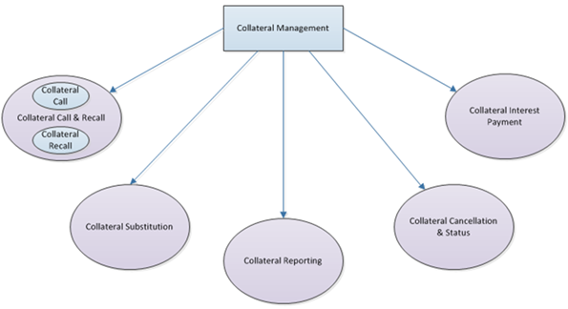

Collateral Call

|  |  |
| --- | --- |
| Item | Description |
| Definition | End to end process of a collateral call, including collateral call issuance, collateral call issuance responses, collateral assignment and responses to proposed collateral assignment and notification of collateral to be moved. It also includes dispute resolution in the case of the rejection of collateral call. |
| Trigger | The process is triggered when a new collateral call is issued. |
| Pre-conditions | None. |
| Post-conditions | The collateral taker receives the collateral. |
| Role | Collateral taker and collateral giver. |

Collateral Recall

|  |  |
| --- | --- |
| Item | Description |
| Definition | End to end process from initial request for a collateral recall and expected responses. |
| Trigger | The process is triggered when a collateral return request is issued or by the termination of an underlying exposure. |
| Pre-conditions | Collateral taker holds collateral. |
| Post-conditions | The collateral giver receives the collateral. |
| Role | Collateral taker and collateral giver. |

Collateral Substituting Process

|  |  |
| --- | --- |
| Item | Description |
| Definition | End to end process from initial request for a collateral substitution and expected responses. |
| Trigger | The process is triggered when a new collateral substitution is requested. |
| Pre-conditions | Collateral is held by the collateral taker or collateral giver. |
| Post-conditions | Collateral is substituted. |
| Role | Collateral taker and collateral giver. |

Collateral Reporting Process

|  |  |
| --- | --- |
| Item | Description |
| Definition | Production of the collateral and exposure report. |
| Trigger | When valuation of the collateral that is posted as at a specific date is required. |
| Pre-conditions | Collateral taker holds collateral. |
| Post-conditions | Report is produced and sent. |
| Role | Collateral taker and collateral giver. |

Collateral Cancellation and Status Process

|  |  |
| --- | --- |
| Item | Description |
| Definition | Process that supports a collateral call being cancelled or a rescind of a collateral call issuance. This process also includes the status messages applicable to these events. |
| Trigger | The process is triggered when a new collateral call is issued. |
| Pre-conditions | None. |
| Post-conditions | The collateral taker receives the collateral. |
| Role | Collateral taker and collateral giver. |

Collateral Interest Payment Process

|  |  |
| --- | --- |
| Item | Description |
| Definition | Process that supports the interest payment notifications and the dispute resolution in case there is no matching of the notifications. |
| Trigger | The process is triggered when an interest notification is issued. |
| Pre-conditions | Cash collateral is held. |
| Post-conditions | Interest amount is agreed. |
| Role | Collateral taker and collateral giver. |

# Description of BusinessActivities

This section presents the different BusinessActivities within each BusinessProcess. The BusinessActivities of a process are described with activity diagrams.

Legend

|  |  |  |
| --- | --- | --- |
| Symbol | Name | Definition |
|  | Start Point | Shows where the lifecycle of the business process commences. |
|  | End Point | Shows where the lifecycle of the business process may ends. |
|  | Lozenge (or diamond) | Indicates that a choice between several actions can be made. |
|  | Bar | Indicates that several actions are initiated in parallel. |

## Margin Call Acceptance & Propose Collateral

This diagram describes the approval, issuance and acceptance of a margin call and the proposal and acceptance of collateral. This activity occurs after the margin call has been approved.

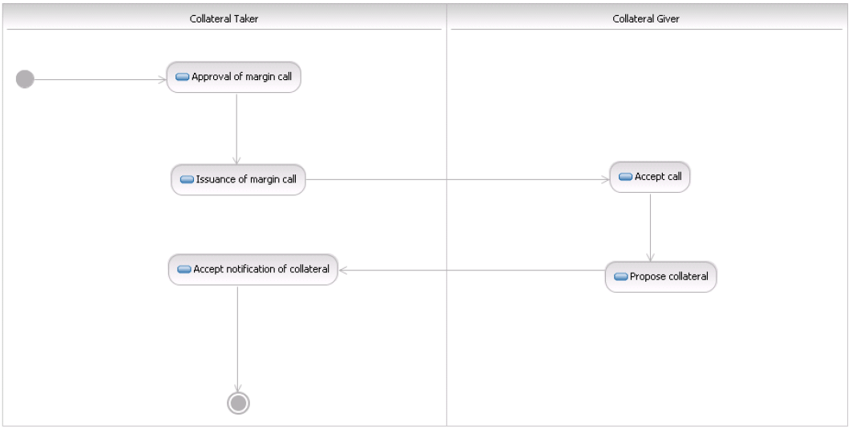

|  |  |  |
| --- | --- | --- |
| Step | Description | Initiator |
| Approval of margin call |  | Collateral Taker |
| Accept margin call | Where the margin call is accepted in full by the collateral giver, an acknowledgement should be returned to the collateral taker. | Collateral Giver |
| Propose collateral | The collateral giver proposes the collateral to be delivered. It may be necessary to specify multiple lines of collateral. | Collateral Giver |
| Acceptance of collateral to be delivered | The collateral taker accepts the proposed type of collateral to be delivered and acknowledgement is provided to the collateral giver. | Collateral Taker |

## Margin Call Proposal Rejection

This diagram describes the rejection of a collateral proposal. This activity occurs after the margin call acceptance and the collateral proposal have been sent.

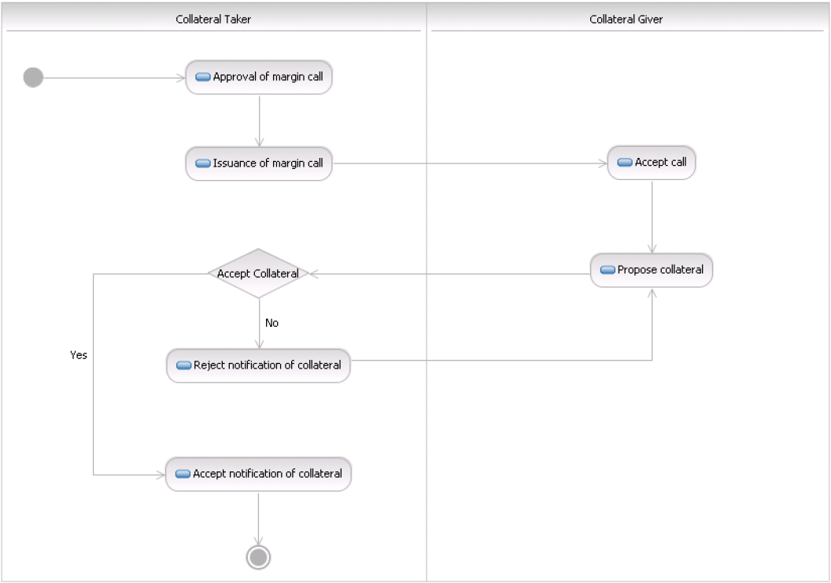

|  |  |  |
| --- | --- | --- |
| Step | Description | Initiator |
| Approval of margin call |  | Collateral Taker |
| Accept margin call | Where the margin call is accepted in full by the collateral giver, an acknowledgement should be returned to the collateral taker. | Collateral Giver |
| Propose collateral | The collateral giver proposes the collateral to be delivered. It may be necessary to specify multiple lines of collateral. | Collateral Giver |
| Accept proposed collateral | Yes or no. | Collateral Taker |
| If no - rejection of collateral to be delivered | The collateral taker rejects the type of collateral to be delivered. | Collateral Taker |
| Counter proposal | The collateral giver will counter by proposing alternative piece/s of collateral to be delivered. It may be necessary to specify multiple lines of collateral. | Collateral Giver |
| If yes-acceptance of collateral to be delivered | The collateral taker accepts the proposed type of collateral to be delivered and acknowledgement is provided to the collateral giver. | Collateral Taker |

## Margin Call Cancellation

This diagram describes the cancellation of a margin call. This activity occurs after the margin call request has been sent.

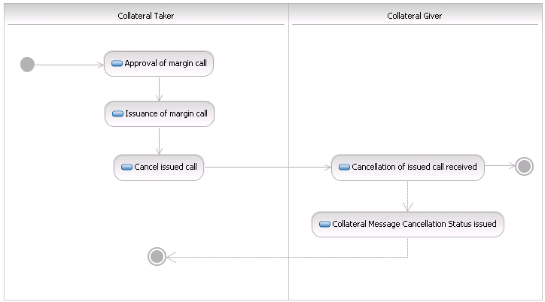

|  |  |  |
| --- | --- | --- |
| Step | Description | Initiator |
| Approval of margin call |  | Collateral Taker |
| Issuance of collateral margin call | The collateral taker issues the margin call. | Collateral Taker |
| Rescind the margin call | The collateral taker should have the option to rescind a margin call, where it has been issued in error. However, this action should not be available once a response, that is, an accept or reject has been received by the issuing party to the margin call. Where a call is rescinded, the process ends. | Collateral Taker |
| OPTIONAL: Collateral message cancellation status | Optionally, the collateral giver confirms the margin call is rescinded. | Collateral Giver |

## Margin Call Dispute

This diagram describes the full or partial dispute of a margin call. This activity occurs after the margin call request has been sent.

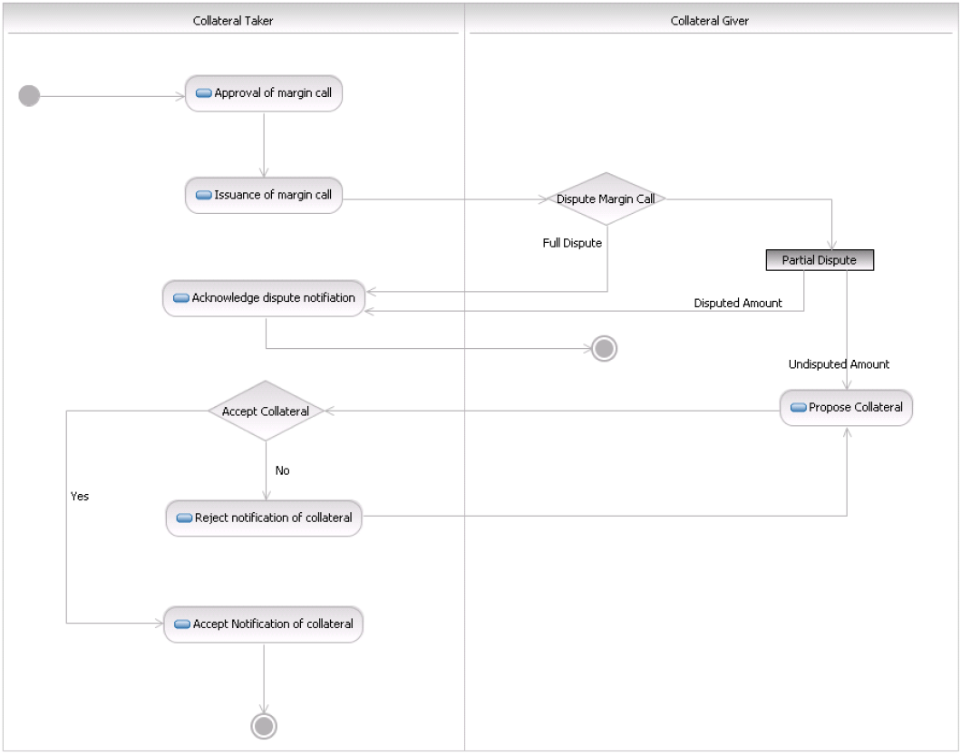

|  |  |  |
| --- | --- | --- |
| Step | Description | Initiator |
| Approval of margin call |  | Collateral Taker |
| Issuance of collateral margin call | The collateral taker issues the margin call. | Collateral Taker |
| How is the margin call disputed? |  | Collateral Giver |
| If a fully disputed margin call | The collateral giver disputes the whole margin call. | Collateral Giver |
| Acknowledge dispute notification | In the case of both a full dispute and a partial dispute, the collateral taker notifies the collateral giver of the disputed amount (whether full or partial). | Collateral Taker |
| If a partially disputed margin call | Where the margin call is partially disputed, an acceptance of the undisputed amount should be provided by collateral giver to collateral taker with proposed collateral to be delivered. It may be necessary to specify multiple lines of collateral. For the disputed amount, the collateral giver is notified of the part of the margin call that is in dispute. | Collateral Giver |
| Accept proposed collateral | Yes or no. | Collateral Taker |
| If no- rejection of collateral to be delivered | The collateral taker rejects the type of collateral to be delivered. | Collateral Taker |
| Counter proposal | The collateral giver will counter and propose alternative piece/s of collateral to be delivered. It may be necessary to specify multiple lines of collateral. | Collateral Giver |
| Acceptance of collateral to be delivered | The collateral taker accepts the proposed type of collateral to be delivered and acknowledgement is provided to the collateral giver. | Collateral Taker |

## Rescind Call Response

This diagram describes when a margin call response is rescinded. This activity occurs after the margin call response has been sent.

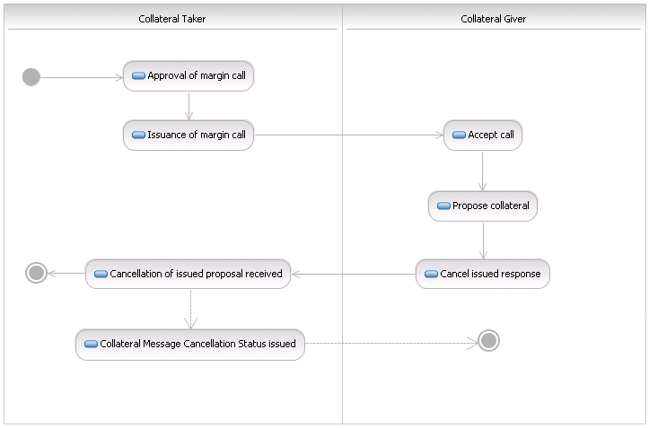

|  |  |  |
| --- | --- | --- |
| Step | Description | Initiator |
| Approval of margin call |  | Collateral Taker |
| Issuance of collateral margin call | The collateral taker issues the margin call. | Collateral Taker |
| Accept margin call | Where the margin call is accepted in full by the collateral giver, an acknowledgement should be returned to the collateral taker. | Collateral Giver |
| Propose collateral | The collateral giver proposes the collateral to be delivered. It may be necessary to specify multiple lines of collateral. | Collateral Giver |
| Rescind margin call response | The collateral giver has the option to rescind its full or partial acceptance of a margin call where it has previously accepted the call in error or can no longer deliver the full amount of the call. The call can be rescinded up until a time as mutually agreed by both parties, which most likely will be up until the funding for the collateral has been locked in by the parties on both sides. | Collateral Giver |
| Optional: collateral message cancellation status. | Optionally, the collateral taker provides the status of the cancellation. | Collateral Taker |

## Accept or Reject Substitution Request

This diagram describes the acceptance or rejection of a substitution request. This activity occurs after the substitution request has been sent. This event can be initiated by either the collateral taker or the collateral giver (in this scenario it is initiated by the collateral giver).

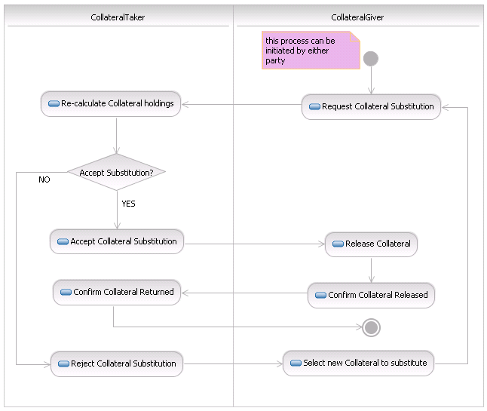

|  |  |  |
| --- | --- | --- |
| Step | Description | Initiator |
| Request collateral substitution | A collateral substitution is requested by the collateral giver, which specifies the collateral to be returned and proposes the new type(s) of collateral to be delivered. | Collateral Giver |
| Agree to collateral substitution | Yes or no. | Collateral Taker |
| In no - reject collateral substitution | The collateral substitution request is rejected by the collateral taker (all or in part) with a rejection reason. | Collateral Taker |
| Propose new line of collateral | The collateral giver proposes a new line(s) of collateral to the original substitution request. | Collateral Giver |
| If yes - accept collateral substitution | Where a collateral substitution is agreed by the collateral taker an acknowledgement is sent to the collateral giver. | Collateral Taker |
| Notification of collateral delivery | Where the collateral giver is the party delivering the collateral, the collateral taker will only release the return of collateral when the new piece of collateral is received. The collateral giver should notify the collateral taker that the collateral substitution, that is, new piece(s) of collateral, have been released or delivered. In the event that multiple pieces of collateral are being delivered in place of the collateral due to be returned by the collateral giver, the notification should only take place once all collateral pieces have been agreed between both parties and have been delivered. | Collateral Giver |
| Acknowledgement of return of capital | The collateral taker confirms that the collateral substitution, that is all pieces have been received, and acknowledges return of collateral. | Collateral Taker |

## Substitution Return Request

This diagram describes when the collateral giver sends the request with ONLY the description of the collateral that it requests to get back, to give as much notice as possible to the collateral taker.

When the collateral giver knows what collateral it will propose to deliver to the taker, the collateral giver will send the collateral substitution request with both the collateral to be returned and the collateral to be delivered. The scenario "Accept or Reject Substitution Request" will then apply.

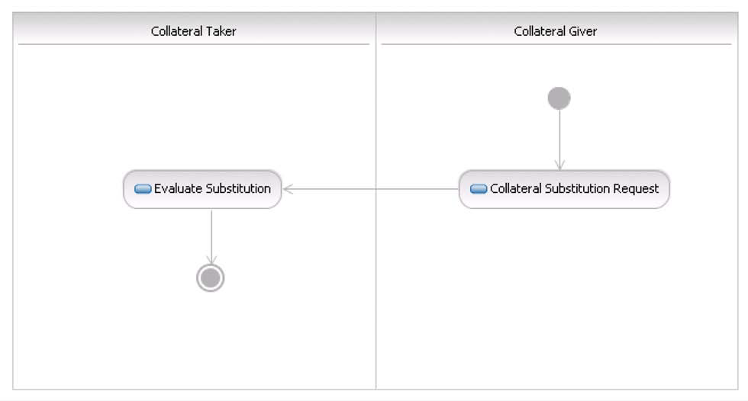

|  |  |  |
| --- | --- | --- |
| Step | Description | Initiator |
| Request collateral substitution | A collateral substitution is requested by the collateral giver, which specifies the collateral that will be requested to be returned ONLY. | Collateral Giver |
| Evaluate collateral substitution | The collateral taker evaluates the collateral that the collateral giver will substitute at a later time. | Collateral Taker |

## Accept Interest Payment Request

This diagram describes the acceptance of an interest payment request. This activity occurs after the interest payment request message has been sent.



|  |  |  |
| --- | --- | --- |
| Step | Description | Initiator |
| Issuance of Interest Payment Request | The issuing party will send an interest payment request to party B. | Collateral Taker |
| Accept the Interest Payment Request | Party B accepts the interest payment request. | Collateral Giver |

## Dispute Interest Payment Request – Value Date Only

This diagram describes the rejection of an interest payment request because of an issue based on the value date only. This activity occurs after the interest payment request message has been sent.



|  |  |  |
| --- | --- | --- |
| Step | Description | Initiator |
| Issuance of interest payment request | The issuing party will send an interest payment request to party B. | Collateral Taker |
| Accept the Interest Payment Request | Party B rejects the interest payment request based on the value date only. | Collateral Giver |

## Dispute Interest Payment Request – Non Value Date Attribute

This diagram describes the rejection of an interest payment request because of a dispute over the terms of the interest payment request (not the value date). This activity occurs after the interest payment request has been sent.

# BusinessTransactions

This section describes the message flows based on the activity diagrams documented above. It shows the typical exchanges of information in the context of a BusinessTransaction.

Solid lines indicate mandatory messages. Dotted lines indicate optional/potential messages.

The diagrams describe the message flows between the central counterparty (CCP) and the clearing member.

## Margin Call

This section illustrates the usage of margin call messages in typical bilateral scenarios. The margin call messages are exchanged between the collateral taker or its collateral manager and the collateral giver its collateral manager.

### Margin Call Acceptance and Propose Collateral

Once a margin call is approved, a collateral taker sends a MarginCallRequest message to the collateral giver and after the collateral giver responds with the MarginCallResponse message, the collateral giver, in turn, sends a CollateralProposal message. The collateral taker accepts the proposal of collateral by sending a CollateralProposalResponse message, with ‘accepted’.

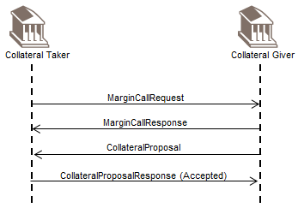

### Margin Call Proposal Rejection

Once a margin call is approved a collateral taker sends a MarginCallRequest message to the collateral giver and after the collateral giver responds with the MarginCallResponse message, the collateral giver, in turn, sends a CollateralProposal message with its initial proposal.

If the collateral proposed is not acceptable, the collateral taker rejects the proposal of collateral by sending a CollateralProposalResponse message with ‘rejected’. The collateral giver then sends a CollateralProposal message with its proposal for alternative piece/s of collateral. If the collateral proposal is rejected again, the collateral giver will have to propose other alternative piece/s of collateral until the collateral taker accepts the nominated collateral.

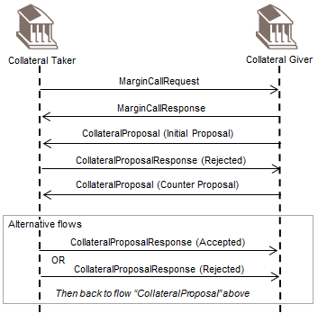

### Margin Call Cancellation

Once a margin call is approved a collateral taker sends a MarginCallRequest message to the collateral giver.

The collateral taker rescinds the MarginCallRequest message and sends a CollateralManagementCancellationRequest message. The collateral giver responds with a CollateralManagementCancellationStatus message.

The margin call cannot be rescinded if the collateral taker has received a MarginCallResponse message with ‘accepted’ (See section 6.1.1 Margin Call Acceptance and Proposal Collateral) or rejected (See section 6.1.4 Margin Call Dispute).

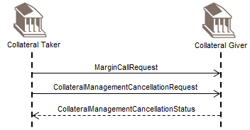

### Margin Call Dispute

This scenario describes the full or partial dispute of a margin call. Once a margin call is approved a collateral taker will issue the margin call by sending a MarginCallRequest message.

Full Dispute

As the margin call is disputed in full the collateral giver sends MarginCallResponse message to the collateral taker disputing the entire margin call.

In the case of a full or partial dispute the collateral taker sends a MarginCallDisputeNotification message to the collateral giver for the disputed amount (whether partial or full). Additionally, for the non-disputed amount the collateral taker accepts or rejects the collateral that is delivered. If the collateral is rejected then the collateral giver must propose alternative piece/s of collateral (See section 6.1.2 Margin Call Proposal Rejection).

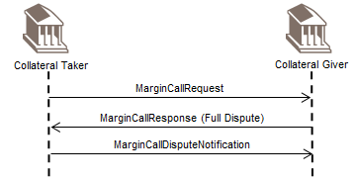

Partial Dispute

If the margin call is only partially disputed then an acceptance of the partial undisputed amount should be provided by the collateral giver to the collateral taker with the proposed collateral.

For the (partially) disputed amount a MarginCallResponse message is returned to the collateral taker disputing the part of the margin call that is not agreed.

In the case of a full or partial dispute the collateral taker sends a dispute notification to the collateral giver for the disputed amount (whether partial or full). Additionally, for the non-disputed amount the collateral taker accepts or rejects the collateral that is delivered. If the collateral is rejected then the collateral giver must propose alternative piece/s of collateral (See section 6.1.2 Margin Call Proposal Rejection).

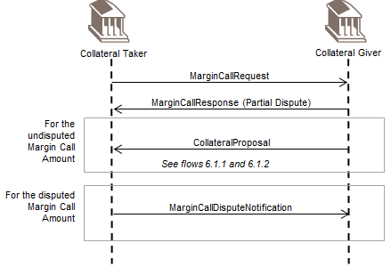

### Rescind Call Response

This scenario describes when a margin call response is rescinded.

The collateral giver has the option to rescind its full or partial acceptance of a margin call where it has previously accepted the call in error or can no longer deliver the full amount of the call. The call can be rescinded up until a time as mutually agreed by both parties, which most likely will be up until the funding for the collateral has been locked in by parties on both sides.

To rescind its MarginCallResponse message, the collateral giver sends a CollateralManagementCancellationRequest message.

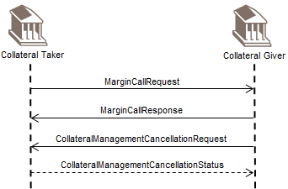

## Substitution

This section illustrates the usage of substitution messages in typical bilateral scenarios. The substitution messages are exchanged between the collateral taker or its collateral manager and the collateral giver or its collateral manager.

### Accept Substitution Request

This scenario describes the acceptance of a substitution request. This event can be initiated by either the collateral taker or the collateral giver.

In this scenario, a CollateralSubstitutionRequest message is sent by the collateral giver, which specifies the collateral to be returned and proposes the new type(s) of collateral to be delivered.

When the substitution is agreed by the collateral taker, it sends a CollateralSubstitutionResponse message with ‘accepted’ to the collateral giver. Where the collateral giver is the party delivering the collateral, the collateral taker will only release the return of collateral when the new piece of collateral is received. The collateral giver sends a CollateralSubstitutionConfirmation message with ‘released’ to notify the collateral taker that the collateral substitution is confirmed, that is, new piece(s) of collateral have been released or delivered.

In the event that multiple pieces of collateral are being delivered in place of the collateral due to be returned to the collateral giver, the CollateralSubstitutionConfirmation message should only be generated once all collateral pieces have been agreed between both parties and have been delivered. The collateral taker confirms that the collateral substitution, that is, all pieces have been received, and acknowledges the return of collateral by sending a CollateralSubstitutionConfirmation message with ‘returned’.

1. There are cases where the collateral taker can initiate the collateral substitution request, for example, in the case of the breach in the concentration limit.

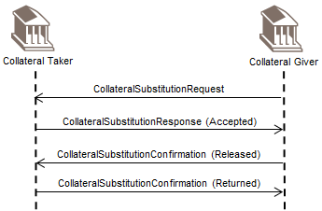

### Reject Substitution Request

This scenario describes the rejection of a substitution request.

A CollateralSubstitutionRequest message is sent by the collateral giver. This specifies the collateral to be returned and proposes the new type(s) of collateral to be delivered.

As the collateral substitution request is rejected by the collateral taker (all or in part), the collateral taker sends a CollateralSubstitutionResponse message with ‘rejected’. The collateral giver proposes a new line(s) of collateral to the original substitution request by sending an updated CollateralSubstitutionRequest message.

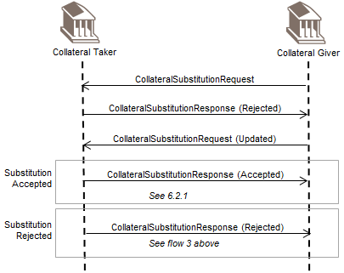

### Substitution Return Request

This scenario is used when the collateral giver sends the request with ONLY the description of the collateral that he requests to get back, to give as much notice as possible to the collateral taker.

When the collateral giver knows what collateral it will propose to deliver to the collateral taker, the collateral give will send a CollateralSubstitutionRequest message with both the collateral to be returned and the collateral to be delivered.

The scenarios "Accept Substitution Request" and "Reject Substitution Request" will then apply. The collateral taker evaluates the collateral that the collateral giver will substitute at a later time.

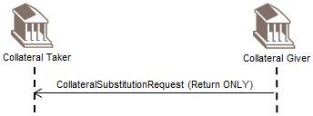

## Interest Payment

This section illustrates the usage of interest payment messages in typical bilateral scenarios. The interest payment messages can be sent by either the collateral taker or the collateral giver.

### Accept Interest Payment Request

This scenario describes the acceptance of an interest payment request. The issuing party, the collateral giver, in this scenario, sends an InterestPaymentRequest message to the counterparty, the collateral taker in this scenario. The collateral taker sends an InterestPaymentResponse message with ‘accepted’.

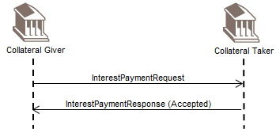

### Dispute Interest Payment Request – Value Date Only

This scenario describes the rejection of an interest payment request due to an issue based on the value date only. The issuing party, the collateral giver in this scenario, sends an InterestPaymentRequest message to the counterparty, the collateral taker in this scenario. The collateral taker rejects the interest payment request based on the value date only, by sending an InterestPaymentResponse message with ‘rejected’. The collateral giver amends the value date and sends an updated InterestPaymentRequest message.

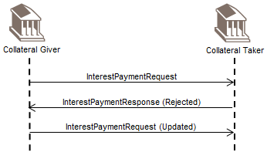

### Dispute Interest Payment Request

This scenario describes the rejection of an interest payment request due to a dispute over the terms of the interest payment request (not the value date). The issuing party, the collateral giver in this scenario, sends an InterestPaymentRequest message to the counterparty, the collateral taker in this scenario. The collateral taker rejects the interest payment request based on an attribute other than the value date and sends an InterestPaymentResponse message with ‘rejected’. The collateral giver amends the interest payment data and sends an updated InterestPaymentRequest message.

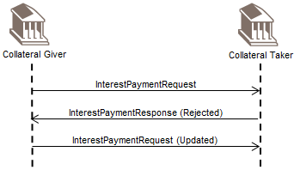

### Interest Payment Statement

The InterestPaymentStatement message is used for reporting the interest per period on collateral held. In the scenario below, the collateral giver sends the statement to the collateral taker.

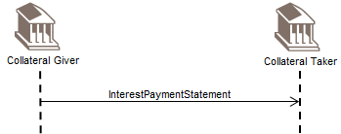

## Collateral Reporting

The CollateralAndExposureReport message is used to provide the details of the valuation of the collateral, that is, the valuation of securities collateral, cash collateral or other type of collateral, posted at a specific calculation date. In the scenario below, the collateral taker sends the CollateralAndExposureReport message to the collateral giver.

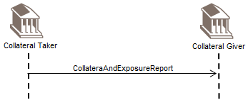

# Revision Record

|  |  |  |  |  |
| --- | --- | --- | --- | --- |
| Revision | Date | Author | Description | Section Affected |
| 1.0 | 1 Dec 2021 | SWIFT | Draft version for SEG review | All |
| 2.0 | February 2022 | SWIFT | Final version | None |

Disclaimer

Although the Registration Authority has used all reasonable efforts to ensure accuracy of the contents of the iso20022.org website and the information published thereon, the Registration Authority assumes no liability whatsoever for any inadvertent errors or omissions that may appear thereon. Moreover, the information is provided on an "as is" basis. The Registration Authority disclaims all warranties and conditions, either express or implied, including but not limited to implied warranties of merchantability, title, non-infringement and fitness for a particular purpose.

The Registration Authority shall not be liable for any direct, indirect, special or consequential damages arising out of the use of the information published on the iso20022.org website, even if the Registration Authority has been advised of the possibility of such damages.

Intellectual Property Rights

The ISO 20022 MessageDefinitions described in this document were contributed by SWIFT. The ISO 20022 IPR policy is available at www.ISO20022.org > About ISO 20022 > Intellectual Property Rights.

1. The word ‘collateral’ is derived from the Medieval Latin *Collateralis*